**SVM**

We can do this with function *tune* given a list of C.

. T compare to random forest This could partly be explained by the fact that this isn’t a linearly separable case.

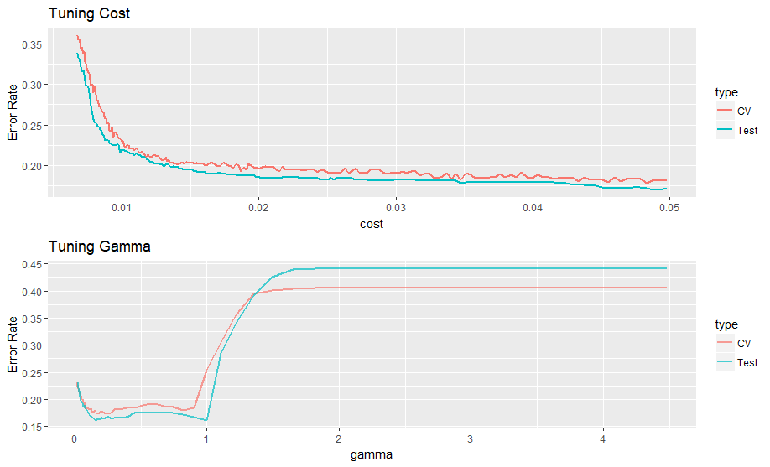

**Confusion Matrix**

|  |  |  |  |  |
| --- | --- | --- | --- | --- |
|  |  | True condition | |  |
|  |  | Non-rain | Rain |  |
| Prediction | Non-rain | 326 | 47 |
| Rain | 54 | 231 |
|  | Error rate | 0.142 | 0.169 | 0.1535 |
|  | Type I | Type II | Overall |

**NYC PART**

Then we use this model for NYC climate data in 2017

**Confusion Matrix**

|  |  |  |  |  |
| --- | --- | --- | --- | --- |
|  |  | True condition | |  |
|  |  | Non-rain | Rain |  |
| Prediction | Non-rain | 72 | 69 |
| Rain | 102 | 121 |
|  | Error rate | 0.586 | 0.363 | 0.4697802 |
|  | Type I | Type II | Overall |

Thus we can conclusion that type I error is 0.586, type II error is 0.363. This model performs not good at predicting the tomorrow precipitation in NYC. And the results for rain days with a wrong prediction is better than non rain days with a wrong prediction.